Comparison between edf motors

The motor that has been choosen for our plane is DS-51-DIA HST® (93mm).

**DS-51-DIA HST ® with DSM4335-950**

Let us now compare it with a motor of higher kv rating **DS-51-DIA HST ® with DSM4341-1050**

**DS-51-DIA HST ® with DSM4341-1050**

Inner jacket diameter: 93 mm  
Geometric throughput area: 51 cm²  
Total weight: 640 g  
Stand thrust range: 53-76 N  
Beam speed: 93-111 m / s  
Speed ​​range: 33,100-39,400  
Input power: 3.5-6.0 kW  
Battery: 10-12S 6000 mAh  
Efficiency: 70-71 %

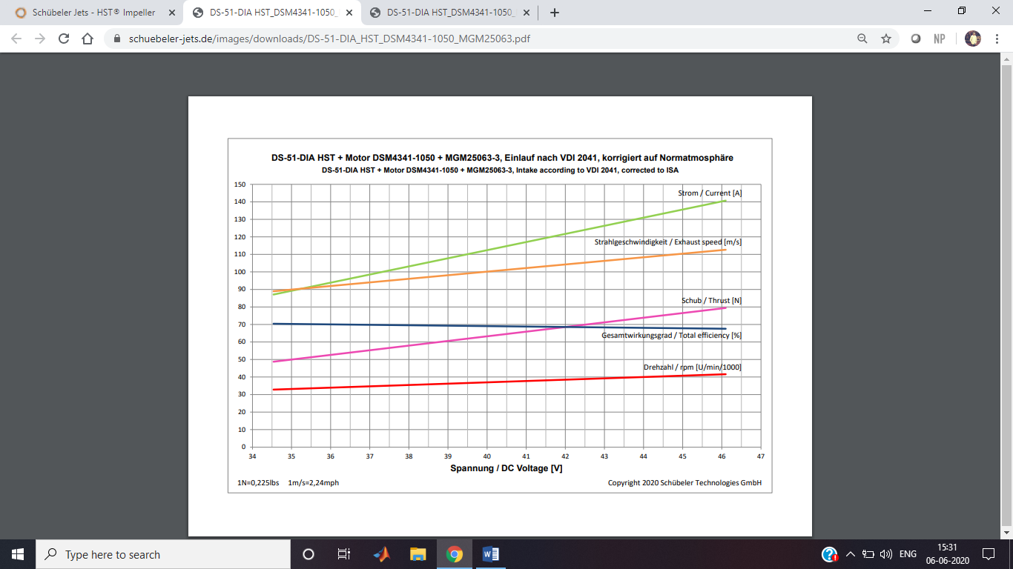

Main reasons for choosing **DS-51-DIA HST ® with DSM4335-950 over   
DS-51-DIA HST ® with DSM4341-1050**

* **The max current drawn by DSM4335-950 is 110A AND min current is 70A**

**Where as in DS-51-DIA HST ® with DSM4341-1050 the max current drawn 140A and min current drawn is 90A**

* **DS-51-DIA HST ® with DSM4335-950 has** Stand thrust range : 41-59 N which is sufficient for the design of our plane
* **Choosing DS-51-DIA HST ® with DSM4341-1050 which is heavier would lead to the choice of a battery with higher capacity and discharge rate and also the size of the battery chosen would increase .Since four such batteries are to be chosen .this would lead In reduction of the total number of balls carried as the size of the plane cannot be increase further**

**Let us compare it with** **DS-82-DIA HST with DSM6029-600**

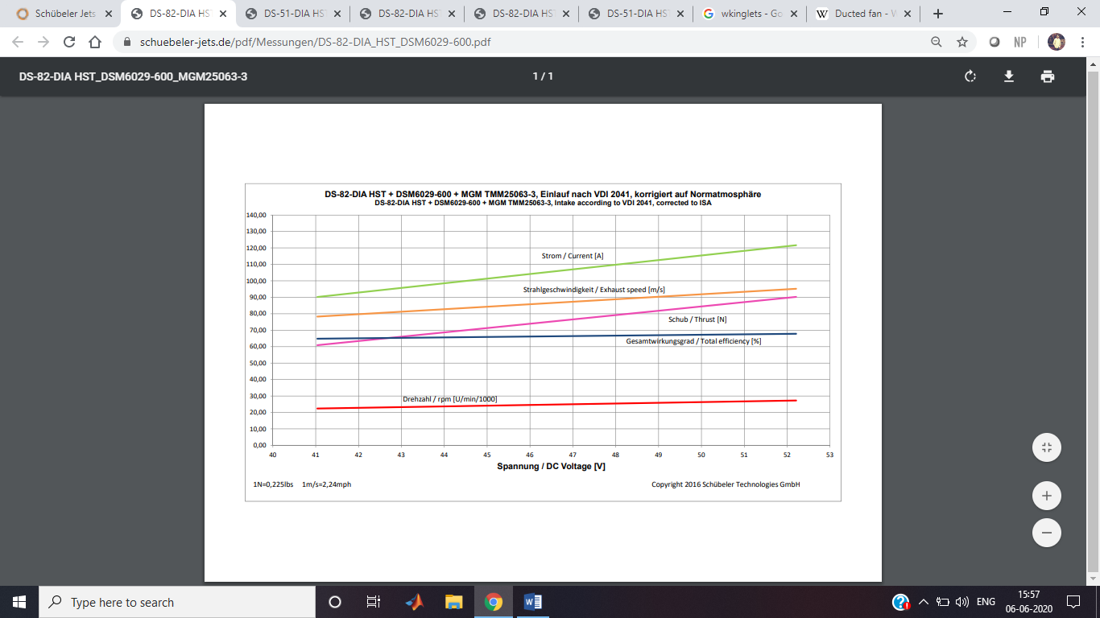

**Main reasons not choosing DS-82-DIA HST with DSM6029-600**

* **This motor less effiecent than DS-51-DIA HST ® with DSM4335-950**
* **This motor draws in a same amount of current it produces same rpm**
* **The space occupied is more compared to the motor chosen by us**
* **This motor is more expensive than the one we choose .**
* **This motor is also heavier**

**Reasons for choosing an electric ducted fan over bldc motor with a unducted propeller**

* By reducing propeller blade tip losses, the ducted fan is more efficient in producing thrust than a conventional propeller of similar diameter, especially at low speed and high static thrust level (airships, hovercraft).
* By sizing the ductwork appropriately, the designer can adjust the fan to allow it to operate more efficiently at higher air speeds than a propeller would.
* For the same static thrust, a ducted fan has a smaller diameter than a free propeller, allowing for smaller equipment.
* Ducted fans are quieter than propellers: they shield the blade noise, and reduce the tip speed and intensity of the tip vortices both of which contribute to noise production.
* Ducted fans can allow for a limited amount of thrust vectoring, something normal propellers are not well suited for. This allows them to be used instead of tiltrotors in some applications.
* Ducted fans offer enhanced safety on the ground

